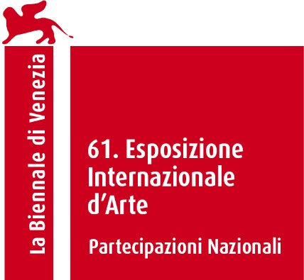

61st International Art Exhibition – La Biennale di Venezia
Hungarian Pavilion

Koronczi Endre: Pneuma Cosmic

The exhibition Pneuma Cosmic is based on a fictional research project that explores the manifestations of the air movement that permeates the entire world. Sectioned into three installations, the ensemble of works explores the artistic possibilities of representing airflow, drawing analogies between the physical phenomenon and the immaterial spiritual world.
Endre Koronczi’s exhibition Pneuma Cosmic presents the hypothesis of an all-pervading, invisibly vitalising, flowing driving force. The project combines the logic of scientific research with an artistic attitudek as well as metaphorical ideas weaving the various concepts together. In the exhibited works, these two different approaches dissolve into presenting a conjecture rather than a proof.
The exhibition is composed of conceptual, ephemeral works that bring attention to the complexity of our intuitive experience of the environment. The elements of the ventilation system removed from the third floor of the listed building of the 200-year-old Hungarian Academy of Sciences, the video installation about the year-long walk to find the most important sigh, the breathing wall of the pavilion, and Máté Balogh’s composition, the acousting element complementing the works, all examine the interaction between the transcendent world and nature. The project is characterised by slowness and contemplative observation combined with abstract, associative thoughts. Albeit poetic and philosophical in its language, the exhibition is closely linked to contemporary discourses on environmental aesthetics and environmental psychology. Repositioning the boundaries between the individual and the outside world may form a new kind of bond and responsibility towards our environment.
Endre Koronczi (1968) is an interdisciplinary artist living in Budapest He is an associate professor at the Media and Design Institute of the Eszterházy Károly Catholic University in Eger. His art is characterised by conceptual thought and poetic sensitivity. In his works, he examines the dynamics of human relationships, everyday situations, and emotions. For decades, he has been exploring the artistic possibilities of visualising airflow by means of outdoor experiments and indoor models.

Commissioner: Julia Fabényi
Curator: Luca Cserhalmi
Exhibitor: Endre Koronczi
Organiser: Ludwig Museum – Museum of Contemporary Art
Venue: Giardini

Press office:
Gabriella Rothman + 36 20 3314033, rothman.gabriella@ludwigmuseum.hu
Zsuzsanna Fehér +36 30 6190710, feher.zsuzsanna@ludwigmuseum.hu

High resolution photos for download: http://vb26press.ludwigmuseum.hu

www.ludwigmuseum.hu
https://pneumacosmic.hu/
www.instagram.com/pneumacosmic/

Main sponsor:
Miniatry of Culture and Innovation
Sponsors: Eszterházy Károly Catholic University – Faculty of Art, KÉSZ Group, K-ARTS Art Foundation

